CS352 Report 2 – Group 12

Penetration Testing: Pro Engineer
2025


Group Members:
Shaneel Singh – S11219489
Krish Rao – S11219601
Shivam Prasad – S11220534
Josephine Mudliar – S11220447

Group Members:
Shaneel Singh – S11219489
Shivam Prasad – S11220534
Krish Rao – S11219601
Josephine Mudliar - S11220447

Abstract
This report focuses on penetration testing conducted on IP address 209.234.212.6 known as PTC Creo. Using Shodan, which scans internet-connected devices to identify exposed systems, we discovered that the site had multiple severe vulnerabilities. These included Apache header hijack, header overload, and buffer overflow. Pen testing was used to identify these flaws and assess the system’s security posture. This process supports key cybersecurity goals: confidentiality, integrity, and availability. By implementing access controls, regular system patching, and security control testing, the organization can address these vulnerabilities. Overall, penetration testing helps manage risk, ensure compliance, improve defences, and minimize cyber attack exposure when conducted ethically by trained professionals.

Table of Content

Introduction 3
Core Cyber security Principles Supported by Penetration Testing: 5
Discussion 7
Test Environment 7
Target Chosen and Methodology Used: 8
Vulnerabilities Identified With its Associated Risks and Respective Recommendations 11
The Process of Penetration Testing: 15
Viable Cybersecurity Measures to Protect the Scenario from Threats 17
Conclusion 21
References 22

Introduction
Shodan is a search engine like Google, but instead of searching for websites, it searches for internet-connected devices. it can quickly disclose information about target devices based on a specific range of IP addresses. Shodan can find anything that connects directly to the internet, and if your internet-facing devices are not protected, it can be used to break into your network.
Penetration test or pen test is the attack simulation on IT systems with the intention of finding security weaknesses that determine how systems react to these weaknesses.
Penetration testing attempts to exploit weaknesses or vulnerabilities in systems, networks, human resources, or physical assets in order to stress test the effectiveness of security controls. The different types of penetration tests include network services, web applications, client side wireless, social engineering, and physical. A penetration test may be performed externally or internally to simulate different attack vectors.
Penetration testing is a technique focused on evaluating the security of a specific system or network. The pen testing process can be broken down into six stages:
- Reconnaissance and Planning – In this stage, information about the target system is gathered to identify potential vulnerabilities.
- Scanning – Tools like war diallers and port scanners are used to detect loopholes and vulnerabilities.
- Obtaining Entry – Testers attempt to gain access to the target system using actual attack methods, such as SQL injections, to expose system weaknesses.
- Maintaining Access – This stage imitates advanced persistent threats, allowing testers to remain connected for as long as possible to maximize data infiltration.
- Analysis – The results of the test are compiled into a report that outlines the vulnerabilities exploited, the type of sensitive data accessed, and the duration of access.
Depending on the goals of each test, a penetration tester may or may not have prior knowledge of the environment and systems they're attempting to breach. This is categorized as black box, white box, and grey box Penetration testing. Penetration testing involves ethical hacker scaling planned attack against a company's security infrastructure to hunt down security vulnerabilities that need to be patched up painting is part of a holistic security strategy [14].
Penetration testing is a critical cybersecurity practice aimed at identifying and addressing vulnerabilities in an organization's IT systems by simulating real-world cyberattacks. It helps organizations discover security weaknesses that attackers could exploit to gain unauthorized access to networks, data, and assets, thereby improving security posture and compliance with standards [19].
The CIA triad is a foundational concept in information security. It consists of three key security features: Confidentiality, Integrity, and Availability.
- Confidentiality ensures that data is accessible only to authorized users. For example, encrypting data prevents unauthorized access. Only individuals with the correct decryption key can view the data, keeping it safe from attackers or internal threats.
- Integrity guarantees that data remains accurate and unaltered unless changed by authorized sources. For instance, using MD5 hash signatures or checksums helps detect any unauthorized modifications. If a file's hash value changes unexpectedly, it indicates that the data has been tampered with.
- Availability ensures that systems and data are accessible to authorized users when needed. For example, implementing DDoS protection or load balancing helps keep websites and applications running smoothly. This is especially important for services like e-commerce platforms, where clients rely on constant access to perform transactions.

Core Cyber security Principles Supported by Penetration Testing:
- Risk Management: Penetration testing supports risk assessment by identifying and prioritizing vulnerabilities based on potential impact [16].
- Defense-in-Depth: Testing verifies multiple layers of security controls and their effectiveness against sophisticated attack methods [17].
- Continuous Improvement: Regular penetration testing helps organizations adapt to evolving threats and improve security posture over time [18].
- Compliance and Assurance: Pen tests provide evidence of security controls effectiveness and help meet regulatory requirements [19]
- Ethical Conduct: Tests must be conducted by skilled, certified professionals following clear objectives, scope, and rules of engagement to ensure ethical and legal compliance [20].

Penetration testing can be used to find and fix security flaws in a variety of scenarios. For instance, testers might mimic phishing emails to trick employees into revealing private information, such login passwords or private information. In a different situation, data is manipulated or extracted via taking advantage of online application vulnerabilities like SQL injection or cross-site scripting. Organizations can use these tests to assess their defences and make sure cybersecurity requirements are being followed [30].

For the scenarios above, it is important to adhere to effective cybersecurity policies and procedures:
- Compliance: complying with significant cybersecurity standards and regulations such as ISO 27001 and HIPAA. Penetration testing that replicates phishing emails is consistent with these policies because it identifies weaknesses in employee behaviour and ensures compliance with controls such as user training or security awareness requirements. Equally, Penetration testing that target web applications vulnerabilities ensures compliance by identifying and addressing exploitable defects, as required by these standards, to prevent unauthorized access or data breaches [31].

- Incident Response: creating and carrying out a response plan to deal with any security failures that can happen during or after penetration testing [33]. In phishing email situations, resetting compromised credentials and reinforcing training are two examples of measures that the incident response plan may direct if employees revealed sensitive information. Similarly, when testing web application vulnerabilities like SQL injection, the policy's objective of efficiently addressing security events is also in line with the response plan, which guarantees quick patching or mitigation in the event that a tester finds exploitable holes.

- Risk mitigation: detects and addresses vulnerabilities, lowering the chance of security breaches and data leaks [32]. Phishing simulation tests help detect weaknesses in human-related security controls. By identifying social engineering vulnerabilities, companies can reduce the risk of data leaks by implementing enhanced email filtering. Testing vulnerable web applications helps in identifying weaknesses that could lead to breaches and leaks. By finding and resolving these problems, organizations are able to reduce risks before they may be used against them.
In summary, penetration testing is a structured, ethical hacking process that identifies security weaknesses, assesses risk, and guides remediation to strengthen an organization's cybersecurity defences in alignment with core cybersecurity principles.[16],[19],[20]. In this report, the website Pro/Engineer Wildfire will be penetrated, identifying its vulnerabilities using Metasploit framework and Nmap utility and recommending measures to protect against those vulnerabilities.

Discussion

Test Environment
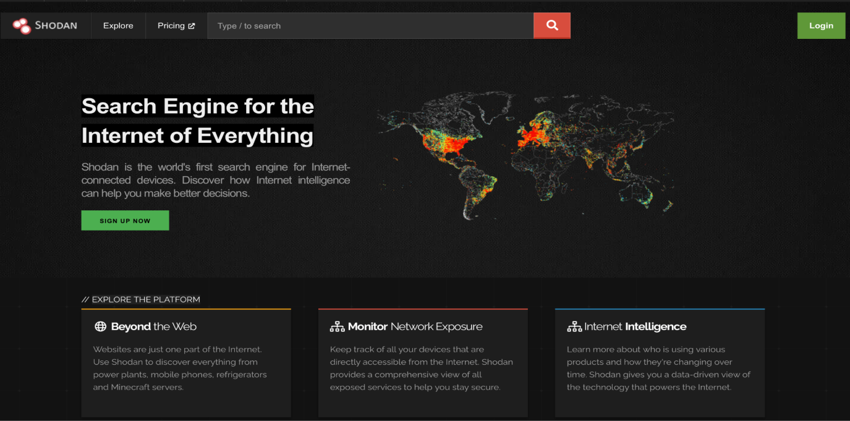
Shodan.io is a unique search engine designed specially to let users browse and find various types of servers, which include webcams, routers and servers, that are connected to the internet [11]. How Shodan works is that it continuously scans the internet by pinging devices on a wide range of protocols and network ports such as HTTP, HTTPS, FTP, SSH and many more [11]. Shodan.io collects these pieces of metadata returned by devices when responding to requests called Service Banners. These Service banners can reveal hidden information such as device type, approximate location, software versions and in some cases even login credentials [12]. Major use cases for Shodan.io include; being used by IT and cybersecurity professionals to identify vulnerabilities, monitor potential risks and to find and correct misconfigured components of the system. Shodan can be used by Cyber professionals in order to conduct Penetration testing as well as to do overall vulnerability analysis. In addition to that, Shodan also helps organizations to discover devices in their system, they may not have known were publicly available, hence allowing them to take actions in order to correct it [13].
Figure 1: Shodan Homepage

Target Chosen and Methodology Used:
This IP chosen for the penetration testing was 209.234.212.6, which belongs to Pro/Engineer Wildfire which is the old version of a website now known as PTC Creo. The Pro/Engineer Wildfire website is no longer available on the web by normal search but using Shodan we gained access to the old website.
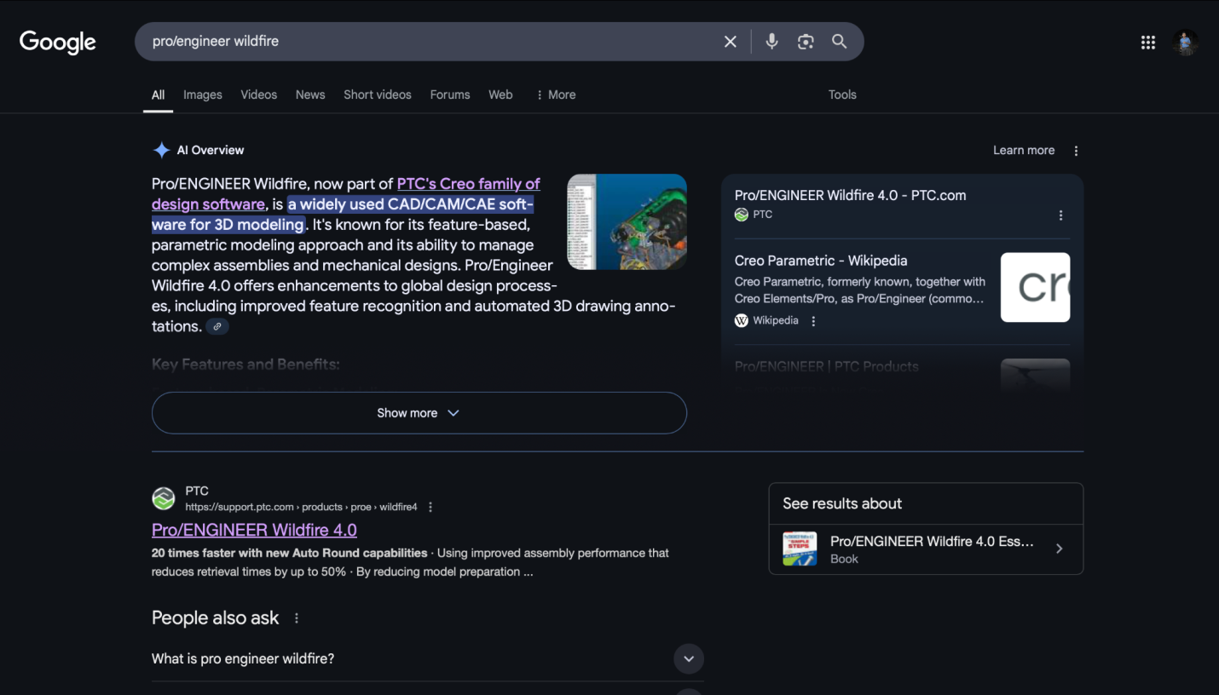
Figure 2: Search Result of Query “Pro/Engineer Wildfire”
The figure above shows that there is no clear result showing the Pro/Engineer Wildfire website. Using the Ip of the exposed port, we gained access to the older version of the website shown below using endpoint: https://https://209.234.212.6/

Figure 3: Old Version of Pro/Engineer Wildfire

Shown below is the current version of the website which pops up when we searched for Pro/Engineer Wildfire. The Website was accessed using: https://www.ptc.com/en/products/creo/pro-engineer
Figure 4: The renamed version of the website
The environment tested was a Apache based Server which had its HTTP/HTTPS services exposed on ports: 443 and 80

Vulnerabilities Identified With its Associated Risks and Respective Recommendations

Vulnerability Code | Vulnerability Name | CCVS score | Severity | Date Of Publication
CVE-2024-38476 | Apache header hijack | 9.8 | Critical | July 01, 2024; 3:15:04 pm -0400
CVE-2024-27316 | HTTP/2 Header Overload | 7.5 | High | April 04, 2024; 4:15:08 pm -0400
CVE-2022-37436 | Apache HTTP Server backend issue | 5.3 | Medium | January 17, 2023; 3:15:11 pm -0500
CVE-2022-28615 | Read beyond bounds in Apache HTTP Server | 9.1 | Critical | June 09, 2022; 1:15:09 pm -0400
CVE-2021-44790 | Buffer Overflow in Apache HTTP Server | 9.8 | Critical | December 20, 2021; 7:15:07 am -0500
Table Source: https://nvd.nist.gov/vuln/search
CVE-2024-38476 - Apache header hijack
CVE-2024-38476 was a vulnerability identified with a CCVS score of 9.8, which marks it as critical severity. This vulnerability was found in the core functionality of the Apache HTTP server in version 2.4.59 and earlier [1]. This flaw arises from improper handling of response headers from the backend, which in return can be used by attackers to breach information [1]. This issue also brought up a risk of another attack, Server-Side Request Forgery (SSRF). SSRF is a vulnerability that allows attackers to cause the server side of the application to make requests to a location which is not intended [2]. For this vulnerability, no active exploit was reported but the risk was considered high due to ease of it being exploited and potential impact of it being exploited [1].

Recommendation:
The first recommendation for the above-mentioned vulnerability is to upgrade to Apache HTTP server version 2.4.60 or later in which the vulnerability has been dealt with. Another recommendation can be that an organization should review and update anything that uses the “AddType” directive in order to connect requests to handlers. Instead, they should use “SetHandler”. In addition to those, implementing monitoring and logging can also help in detecting unusual activities allowing for timely response and lower overall damage [1].

CVE-2024-27316- HTTP/2 Header Overload
CVE-2024-27316 was a vulnerability identified with a CCVS score of 7.5, which marks it as high severity. The above is a vulnerability in the Apache HTTP server, version 2.4.17 through 2.4.58, which is responsible for the handling of HTTP/2 continuation frames which are used to transmit headers larger than the maximum frame size [3][4]. An attacker can potentially exploit this vulnerability in order to cause a Denial of Service (DoS) Attack. The DoS attack would take place following the actions of the attacker sending a continuous stream of frames which would cause the server to exhaust its memory resources [4]. In addition to that, studies show that there were many exploitations for this vulnerability and some might still be available [3].
Recommendation:
The first recommendation for the above-mentioned vulnerability would be to upgrade to Apache HTTP server 2.4.59 or later, and configure the limits on HTTP/2 headers. Another recommendation would be to monitor abnormal memory usage in order to flag suspicious CONTINUOUS frames being sent. In addition to those, organisations should consider using web-based firewall applications to block malicious HTTP/2 requests [5].

CVE-2022-37436 - HTTP Server Backend Issue
CVE-2022-37436 was a vulnerability identified with a CCVS score of 5.3, which marks it as medium severity. This vulnerability was discovered in Apache HTTP server versions 2.4.55 and before [3]. It would allow a malicious backend to cause the shortening of response headers which would result in some HTTP headers being incorporated into the actual body of the response message instead of being properly interpreted by the receiving client [6]. Certain issues could arise if it the vulnerability is exploited, these include; web cache poisoning, HTTP response splitting and cross site scripting [7].

Recommendation:
The primary action to take would be to upgrade to Apache version 2.4.56 or higher as the vulnerability is patched in those versions. Another mitigation strategy could be to avoid interaction with unknown backends as this vulnerability exploits malicious backends [7]. In addition to that, it is recommended that activity and request monitoring software’s be implemented in order to scan for and flag suspicious activities.

CVE-2022-28615- Read beyond bounds in Apache HTTP Server
CVE-2022-28615 was a vulnerability identified with a CCVS score of 9.1, putting it in the critical severity criteria. It was mainly affecting Apache HTTP server version 2.4.53 and earlier [3]. The vulnerability was caused by a read beyond bounds in one of the functions when it would process an extremely large input buffer [3]. The above-mentioned flaw can lead to major server crashes or disclosure of important information. In addition to that, there has been no confirmed or active exploits targeting this vulnerability [8]
Recommendation:
The first action to take would be to upgrade Apache HTTP Server to version 2.4.52 or later where the above-mentioned vulnerability is patched. Apart from the upgrading of affected servers, no other workaround has been discovered for this vulnerability making it quite a threat [3].
CVE-2021-44790 - Buffer Overflow
CVE-2021-44790 was a vulnerability discovered with a CCVS score of 9.8, hence making it into the critical severity category. It is a buffer overflow vulnerability in Apache HTTP server version 2.4.51 and earlier [3]. The vulnerability was specifically found in one of the functions called from Lua scripts [9]. An attacker could carefully craft a request body in order to trigger this buffer overflow. Once this vulnerability has been triggered, it can cause a Denial of Service (DoS) attack or allow the attacker to remotely execute code. In addition to that, there are currently no public exploitations of this vulnerability but it is believed that it can be crafted, hence making it quite a dangerous vulnerability [3].
Recommendation:
The primary course of action would be to upgrade to Apache HTTP Server version 2.4.52 or later where this issue is fixed. Another recommendation would be to monitor the system for suspicious activities which could lead to potential remote code execution or Denial of service attacks [10]. In addition to that, the organization should review their use of Lua scripts in Apache to ensure they do not process content which may cause buffer overflow hence minimizing exposure.

The Process of Penetration Testing:
Step 1: Reconnaissance and Planning:
The Ip found using shodan.io was used in conjunction with the nmap framework in order to do recombinase. This is done to find open the open ports related to the IP address
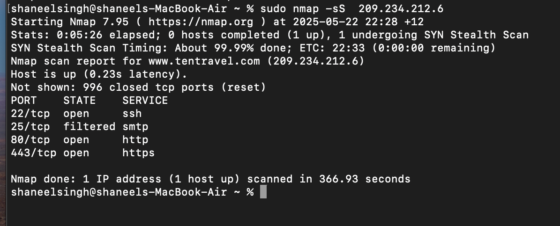
Once completed, the scan showed us the port numbers and its state, whether it was open or not. Once the scanning was completed, testing of the Ip was done in order to find any current vulnerabilities.
Step 2: Scanning for current vulnerabilities:
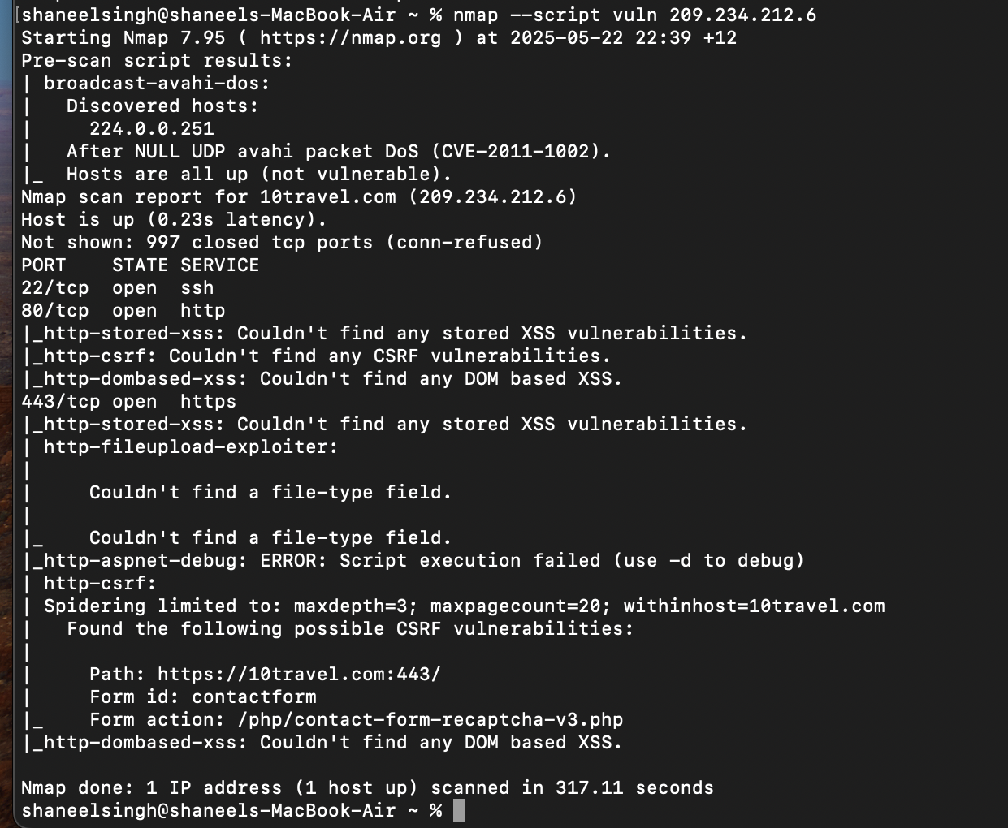
Based on the Scan results, it was concluded that there were no CURRENT vulnerabilities detected on any of the ports which meant that further steps in the Penetration testing could not take place.

Viable Cybersecurity Measures to Protect the Scenario from Threats
- Use of HTTP Security Headers
HTTP security header passes additional security features and information with HTTP requests or responses. One example is the X- Frame- Options header. This is a security header with a purpose to protect websites and applications being injected with malicious content [21]. It provides robust control on how the page is embedded. It also provides protection against click baits and gaining unauthorized access [22]. It provides details of whether or not a browser should be allowed to render a page in a <frame>, <iframe>, <embeded> or <object> [23].
- Limiting the Header Size
Configuring servers to have a limit of HTTP/2 headers per request. By configuring this setting, excess requests will not be allowed to process thus reducing the chance for the header to overload. The Apache Tomcat uses the attribute “maxHeaderSize” to regulate header overload. This attribute contains the maximum size of headers that is allowed in a request by the container [24].
- Regular Patch Management
Patch management is the process where IT specialists deploy relevant updates to software, firmware, drivers and API’s [25]. The process of patch management involves:
- Inventory - Involves identifying the hardware, drivers, software that needs patching [25].
- Prioritization - Ranking of vulnerabilities and risk according to the severity [25]
- Testing - Testing of the patches in a separate test server in order to check if all the patches work before sending it for deployment [25]
- Deployment - Installing of the updated patches in the organization or software [25]
- Verification - Verifies that the patches deployed have been installed successfully [25]
- Reporting - Providing detailed documentation of the patched status for compliance to the international standards.
- Access Control
Access control is a mechanism that controls or regulates the accessing of particular information in computing environment [26]. It ensures that there is no unauthorized access to the information. Access control can have five components, these include:
- Authentication
This verifies that a person or a computer user belongs to the system. Authentication mechanisms include credentials, digital certificates of websites and validation of login credentials [27]
- Authorization
These are the privileges and the authority given to a person or computer user the authority to do a particular job. Authorization process defines privileged accounts in the network and provides high level control [27]
- Access
This includes how users access the information after authentication and authorization process is completed [27]
- Administration
Extensive management of an access control system is performed. The activities involved are addition and the removal of accounts, and also making it possible to control access of database administrator to important database [27]
- Control
Regular inspection is carried out in order to prevent users from taking tasks where they are not authorized in the process, thus reducing cyber threats [27]
- Continuous Security Control Testing
Security control refers to the process of evaluating the security measure the organization has placed to protect their system and environment. It is important to carry out regular security control testing as it is able to identify weakness in the security measures implemented [28]. This also ensures compliance with industry standards and regulation. Activities that are carried out during security control testing involves:
- Planning
In this stage, information about the targeted system is carried out by the penetration testers. This information is used to analyse and identify key security controls and their entry points [28].
- Scanning
Penetration testers make use of tools to identify vulnerabilities through scanning the targeted system. The tools help in understanding the security controls and how they function [28]
- Exploitation
This is the stage where ethical hackers and penetration testers make an attempt to exploit the system. The purpose is to determine if the implemented security control can be bypassed [28]
- Post – Exploitation
In this stage, testers assess and analyse the impact on the system [28]. This assesses the data accessibility and the potential impact of the security breach.
- Reporting
This stage involves documenting and compiling a detailed report of findings. This report includes the impacts, vulnerabilities and their associated recommendation [28].

Conclusion
This report has provided insights into what Shodan is and what its purpose is. Penetration testing is a very important aspect in cybersecurity as it is used to identify and address vulnerabilities in the system of an organisation. The penetration test was conducted on the Pro/ Engineer Wildfire Website which had many severe vulnerabilities. Apache header hijack, header overload, buffer overflow was some of the vulnerabilities that were identified in the website. By adhering to the cybersecurity measures such as the implementation of access control, regular patching of system software and security control testing, the organisation can curb its vulnerabilities and make their website more secure. With the help of penetration testing, an organisation can minimise cyber attacks and make systems safer and more secure.

References
[1] Rescana, “Critical Apache HTTP Server Vulnerability CVE-2024-38476: Mitigation and Protection Strategies,” Rescana, Oct. 22, 2024. https://www.rescana.com/post/critical-apache-http-server-vulnerability-cve-2024-38476-mitigation-and-protection-strategies (accessed May 14, 2025).
[2] PortSwigger, “What Is SSRF (Server-side Request forgery)? Tutorial & Examples | Web Security Academy,” portswigger.net, 2023. https://portswigger.net/web-security/ssrf
[3]Apache, “httpd 2.4 vulnerabilities - The Apache HTTP Server Project,” Apache.org, 2019. https://httpd.apache.org/security/vulnerabilities_24.html
[4] V. V. Sehgal, “Exploiting HTTP/2 CONTINUATION frames for DoS attacks,” Snyk, Apr. 08, 2024. https://snyk.io/blog/exploiting-http-2-continuation-frames-dos-attacks/
[5] SOCRadar, “CVE-2024-27316 - CVE Details & Analysis | SOCRadar Labs CVE Radar.” https://socradar.io/labs/app/cve-radar/CVE-2024-27316
[6] “CVE-2022-37436 : Prior to Apache HTTP Server 2.4.55, a malicious backend can cause the response h,” Cvedetails.com, 2022. https://www.cvedetails.com/cve/CVE-2022-37436/ (accessed May 14, 2025).
[7] “CVE-2022-37436: Apache HTTP Server Vulnerability Overview,” Clouddefense.ai, 2022. https://www.clouddefense.ai/cve/2022/CVE-2022-37436 (accessed May 14, 2025).
‌[8] Rescana, “Critical vulnerability alert: CVE-2022-28615 in Apache HTTP Server (Versions 2.4.53 and earlier),” Rescana, Oct. 22, 2024. https://www.rescana.com/post/critical-vulnerability-alert-cve-2022-28615-in-apache-http-server-versions-2-4-53-and-earlier#:~:text=
[9] “Security Bulletin: Apache HTTP Server as used by IBM QRadar SIEM is vulnerable to buffer overflow and denial of service (CVE-2021-44790, CVE-2021-34798, CVE-2021-39275),” Ibm.com, Feb. 28, 2022. https://www.ibm.com/support/pages/security-bulletin-apache-http-server-used-ibm-qradar-siem-vulnerable-buffer-overflow-and-denial-service-cve-2021-44790-cve-2021-34798-cve-2021-39275 (accessed May 14, 2025).
[10] J. Barnard, “Security Advisory - CVE - 2021 - 44790 - Apache HTTP Server | Pentesec,” Pentesec, Dec. 24, 2021. https://pentesec.com/blog/security-advisory-cve-2021-44790-apache-http-server/ (accessed May 14, 2025).
[11] “Shodan (website),” Wikipedia, Sep. 02, 2020. https://en.wikipedia.org/wiki/Shodan_(website)
‌[12] “Quickstart Shodan: What is it and how does it work,” Cloudsek.com, Jul. 15, 2020. https://www.cloudsek.com/blog/quickstart-shodan-what-is-it-and-how-does-it-work
[13 ]Manish Shivanandhan, “Shodan – What to Know About the Internet’s Most Dangerous Search Engine,” freeCodeCamp.org, Sep. 10, 2024. https://www.freecodecamp.org/news/shodan-what-to-know-about-the-internets-most-dangerous-search-engine/
[14]Cloudflare, "What is penetration testing?", Cloudflare, [Online]. Available: https://www.cloudflare.com/learning/security/glossary/what-is-penetration-testing/. [Accessed: 18-May-2025].
[15]‌SecureTriad, “Penetration Testing Stages [Online image],” SecureTriad.io, Jun. 2021. [Online]. Available: https://securetriad.io/wp-content/uploads/2021/06/penetration-testing-stags.png.webp
[16]EC-Council, “Penetration Testing Phases,” EC-Council, [Online]. Available: https://www.eccouncil.org/cybersecurity-exchange/penetration-testing/penetration-testing-phases/. [Accessed: 18-May-2025].
[17]CyberExperts, "Guide to Cyber Security Penetration Tests," CyberExperts.com. [Online]. Available: https://cyberexperts.com/guide-to-cyber-security-penetration-tests/. [Accessed: 18-May-2025].
[18]National Cyber Security Centre, “Penetration testing,” National Cyber Security Centre – NCSC.GOV.UK. https://www.ncsc.gov.uk/guidance/penetration-testing (accessed May 18, 2025).
[19]Tenable, “Penetration Testing Principles,” Tenable, [Online]. Available: https://www.tenable.com/principles/penetration-testing-principles. [Accessed: 18-May-2025].
[20]Cybersecurity Insiders, “Best Practices in Penetration Testing: Ensuring Robust Security,” Cybersecurity Insiders. [Online]. Available: https://www.cybersecurity-insiders.com/best-practices-in-penetration-testing-ensuring-robust-security/. [Accessed: 18-May-2025].
[21] “Indusface,” Indusface, Feb. 10, 2025. https://www.indusface.com/learning/x-frame-options/ (accessed May 18, 2025).
[22] “How to secure against clickjacking in Apache,” Simplified.guide, 2023. https://www.simplified.guide/apache/prevent-clickjacking
[23] “HTTP headers | X-Frame-Options,” GeeksforGeeks, Oct. 18, 2019. https://www.geeksforgeeks.org/http-headers-x-frame-options/
[24] “Apache Tomcat 8 Configuration Reference (8.5.100) - The HTTP2 Upgrade Protocol,” Apache.org, Mar. 19, 2024. https://tomcat.apache.org/tomcat-8.5-doc/config/http2.html (accessed May 18, 2025).
[25] C. Avey, “What Is Patch Management and Why Is It Important?” www.secureworld.io, Feb. 07, 2024. https://www.secureworld.io/industry-news/why-is-patch-management-important
[26] Frontegg, “Access Control in Security: Methods and Best Practices,” FRONTEGG, Feb. 07, 2024. https://frontegg.com/guides/access-control-in-security
[27] “Why is Access Control Important? | Krontech,” krontech.com. https://krontech.com/why-is-access-control-important
[28] Kate, “Security Controls Testing in Penetration Testing,” Vertex Cyber Security, Jun. 13, 2024. https://www.vertexcybersecurity.com.au/security-controls-testing-in-penetration-testing/ (accessed May 18, 2025).
[29] ‌Firch, Jason. “What Are the Types of Penetration Testing?” PurpleSec, PurpleSec, 25 Feb. 2024, purplesec.us/learn/types-penetration-testing/.
[30] Zhydkova, Tania. “Top 6 Most Common Vulnerabilities Found during Penetration Testing | Aqua Cloud.” Aqua Cloud - Best Software for Testing, 2 May 2023, aqua-cloud.io/6-most-common-vulnerabilities-found-during-penetration-testing/. Accessed 26 Apr. 2024.
[31] Fox, Jacob. “Pentesting Compliance Requirements Overview | Cobalt.” Www.cobalt.io, 30 May 2023, www.cobalt.io/blog/pentesting-compliance-requirements-overview.
[32] “Complete Guide to Cybersecurity Testing: Methods & Types.” Redzonetech.net, 2024, www.redzonetech.net/services/cyber-security-testing.
[33] “The Complete Guide to Penetration Testing.” CyberCX, 21 July 2024, cybercx.co.nz/resource/penetration-testing-guide/. Accessed 23 May 2025.

